**C4 Architecture**

*Project: CinemaWorld*

|  |
| --- |
| Date: 7/10/2021 |
| Version: 1.0 |
| State: Draft |
| Author: Kristiyan Balev |

# 1. C1 – System Context Diagram

# 2. C2 – Overall shape

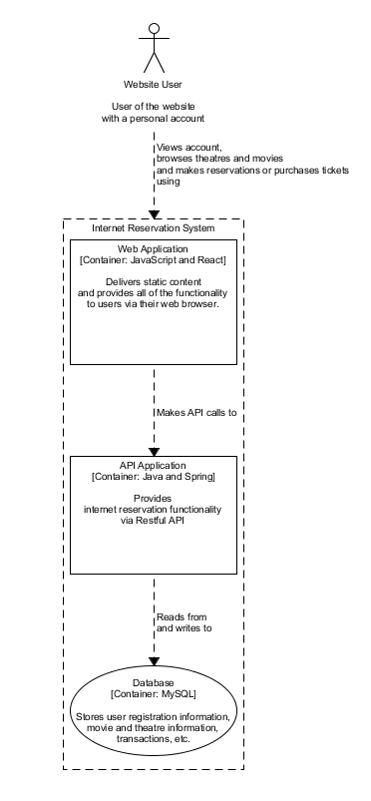

# 3. C3 – Components and their interactions

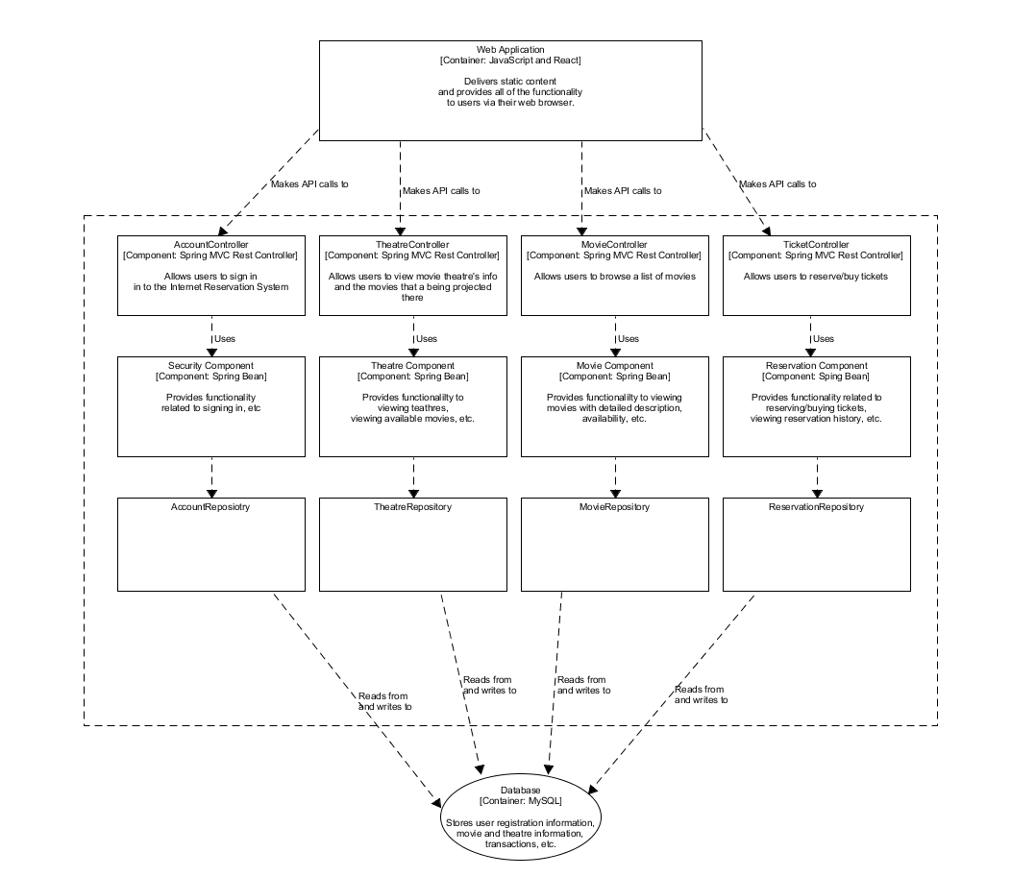

# 4. C4 – Implementation details